SQL PROJECT

Subscription-Based Content Management System Documentation

-------------------------------------------------------------------------------------------------

**NAME: RUCHIKA RAJESH BORHADE**

**COURSE: MASTER IN DATA SCIENCE AND ANALYTICS WITH AI**

**Abstract:**

Designed to streamline the management and distribution of digital content, SB-CMS leverages subscription-based access models to offer scalable, secure, and customizable solutions for content creators and distributors. The system is engineered to facilitate various subscription tiers, manage user access efficiently, and integrate seamlessly with diverse content types and delivery channels.

**Introduction:**

This SQL project involves designing and implementing a database for a Subscription-Based Content Management System. The system manages users, subscription plans, content, and payments. It allows users to subscribe to various content tiers, access categorized content, and track their subscriptions and payments. Key functionalities include user registration, subscription management, content access tracking, and payment processing. The database schema includes tables for users, subscriptions, categories, content, payments, and user-content access logs, ensuring efficient data organization and retrieval.

---------------------------------------------------------------------------------------------------------

**AVAILABLE TABLES:**

* Users: The Users table stores information about individuals who interact with the system, whether they are subscribers, administrators, or content creators. This table serves as the central repository for user data.
* Subscriptions: The Subscriptions table contains details about the various subscription plans available within the system. This includes information on pricing, features, and access levels for each plan.
* UserSubscriptions: The UserSubscriptions table tracks which users are subscribed to which plans. It manages the relationship between users and their subscription plans, including the subscription status and renewal details.
* Categories: The Categories table organizes content into different categories for easier navigation and management. This helps users and administrators find relevant content more efficiently.
* Content: The Content table holds information about the digital content available through the CMS. This includes articles, videos, courses, or any other type of content managed by the system.
* Payments: The Payments table records all payment transactions related to user subscriptions. This includes payment amounts, dates, and statuses, and is essential for managing financial aspects of the system.
* ContentAccess: The ContentAccess table manages the access control for content based on user subscriptions. It ensures that users can only access content that aligns with their subscription level.

**EER DIAGRAM:**

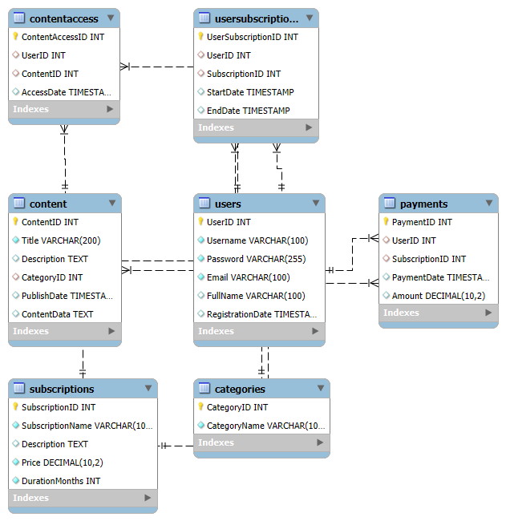

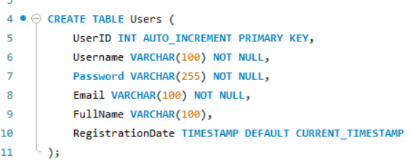

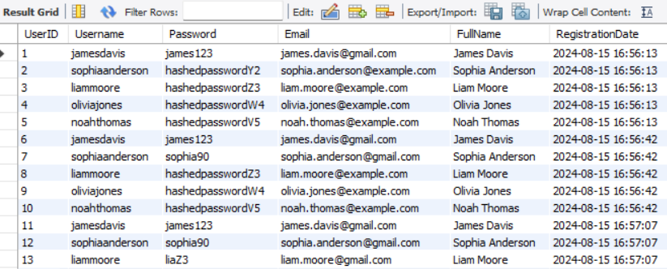

Find user details for a specific username ('jamesdavis'):

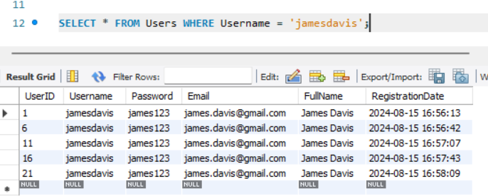

List all subscription plans with their prices:

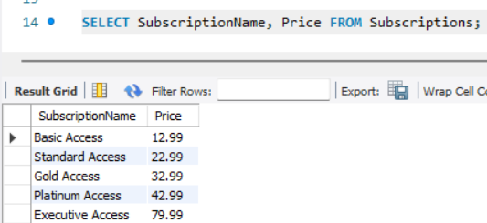

Get all content in the 'Technology' category:

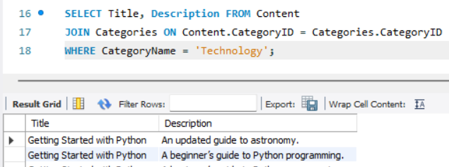

Find the number of users with each subscription type:

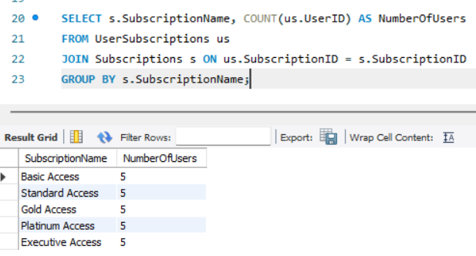

Retrieve all content accessed by a specific user (UserID = 1):

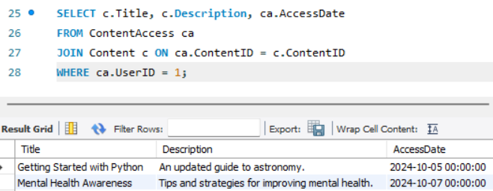

Get the total amount paid by each user:

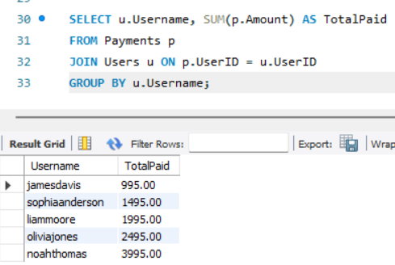

Find the most expensive subscription plan:

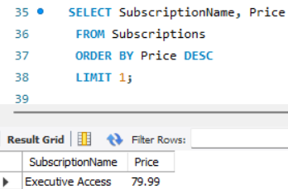

List all content titles and their categories:

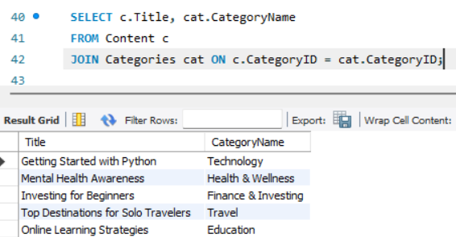

Retrieve all content that has not been accessed by any user:

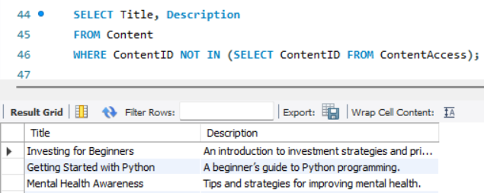

List all users who have accessed more than 2 pieces of content:

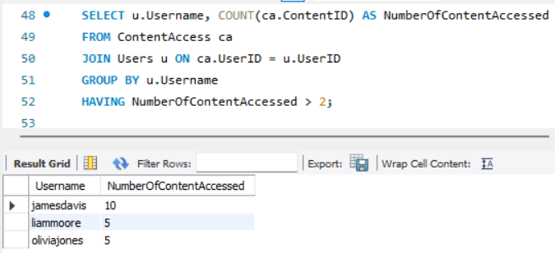

Find the average price of all subscriptions:

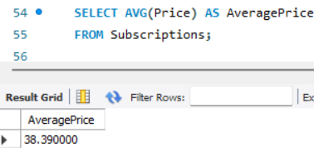

Get the most recent payment date for each user:

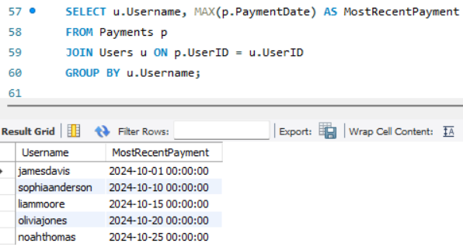

List all categories and the number of content items in each category:

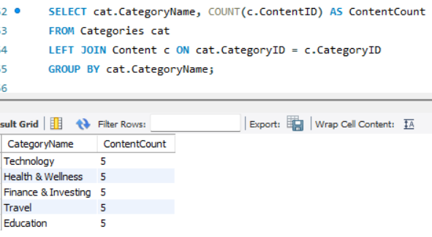

Retrieve all subscriptions with a duration of more than 6 months:

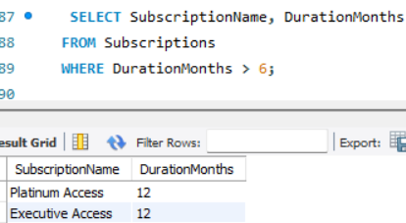

List the top 3 most popular content pieces based on the number of accesses:

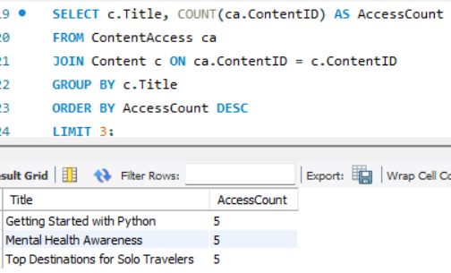

Find the total number of subscriptions purchased by each user:

